Most data in Nomis is arranged in statistical geographies – ranging from the whole of the UK to small output areas, making nomisr a useful tool for map-making and social geography. The example below shows how to retrieve the latest data on the number of Job Seekers Allowance claimants in each parliamentary constitutency, and maps them onto a cartogram from the [parlitools](https://cran.r-project.org/package=parlitools) package, using the [development version of ggplot2](http://github.com/tidyverse/ggplot2/)

library(nomisr)

library(dplyr)

library(parlitools)

library(viridis)

#devtools::install_github("tidyverse/ggplot2/")

library(ggplot2)

library(sf)

jsa_constits <- nomis_get_data(id = "NM_1_1", time = "latest",

measures = 20100, sex = 7,

geography = "TYPE460",

additional_queries = "&item=1")

jsa_constits$GEOGRAPHY_NAME <- gsub("Na h-Eileanan An Iar",

"Na h-Eileanan an Iar",

jsa_constits$GEOGRAPHY_NAME)

jsa_constits$GEOGRAPHY_NAME <- gsub("St ", "St. ", jsa_constits$GEOGRAPHY_NAME)

west_hex_map <- parlitools::west_hex_map %>%

inner_join(jsa_constits, by = c("constituency_name" = "GEOGRAPHY_NAME"))

west_hex_map$OBS_VALUE <- as.numeric(west_hex_map$OBS_VALUE)

p1 <- ggplot(west_hex_map) + geom_sf(aes(geometry = geometry,

fill = OBS_VALUE), color = "black") +

coord_sf(datum = sf::st_crs(west_hex_map$geometry)) +

scale_fill_viridis(option = "E") +

labs(title = "JSA Claimants per Constituency", fill = "JSA Claimants")

p1

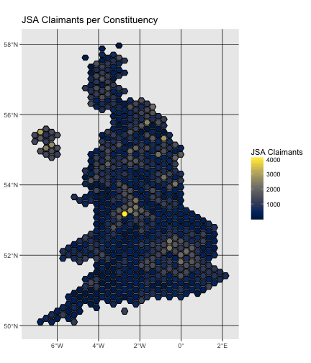

nomisr was developed to make using UK labour market statistics faster, easier and more replicable. I’ve used it to speed up research for policy and issue briefings in my day job

**To do**

The nomisr package covers most of the features available on Nomis, with the exception of a grouping function that can easily be replicated in R using tools like [dplyr](https://cran.r-project.org/package=dplyr) and that will likely be incorporated into a future release, as will an optional parameter to change variable names to snake_case instead of the API’s default all caps response. Long term development is focused on making the package more user-friendly for people with less familiarity with Nomis data and the API structure.